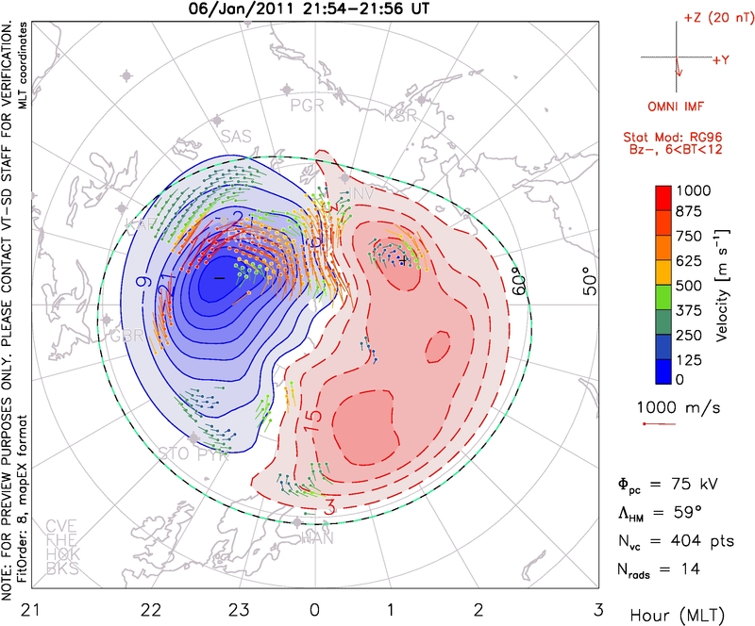

At 2220, the calculated time and seen from All-Sky, the auroral activity starts to happen, and we should expect a high velocity convection as well as high (fi), but the potential is still low. Only around 5 minutes later, we see that the velocity increases considerably than 5 minutes ago. And more 5 minutes later, the pattern is essentially what we will see until around 0000.

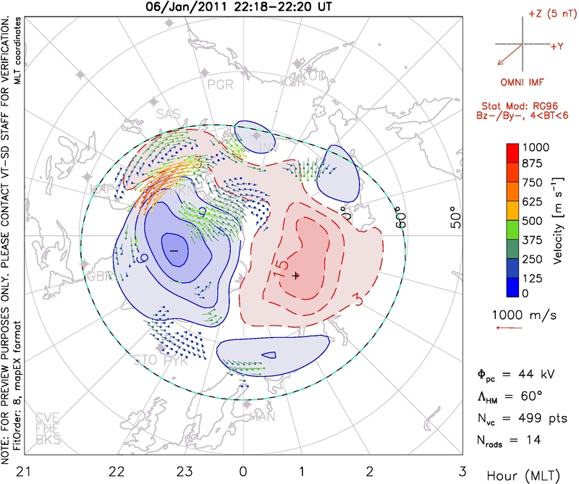
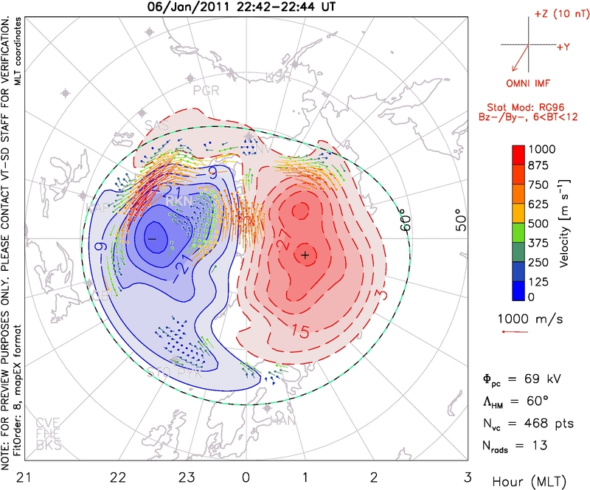
One of the maximum values for the potential and also for the velocities, where in some regions, it is around 1000 m/s, happens between 2248-2250, with the potential measured as 79kV, and the polar cap size is the largest of the pictures shown.
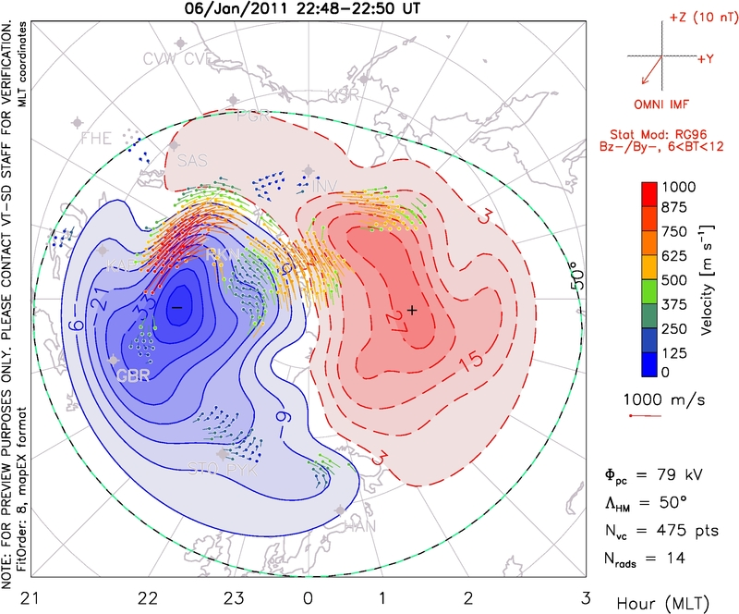

Discussion: By investigating information about the magnetic field on Earth, as well as the generated currents and the plasma convection, it was possible to study the magnetic reconnection phenomena, where the IMF lines connect to the Earths B-lines; the result of this in our planet is the Dungey cycle which is possible because of reconnection.

Before that, the field-aligned currents in the Earth are not intense, and there are few variations, as well as the plasma convection in the ionosphere, where the electric potential observed is the predicted for quiet times, which are the times when there is no magnetic reconnection. Also the magnetic field of the Earth is almost constant, if looking this magnetic activity for some hours, as in the first picture for the magnetometer. However, when we have a southward IMF, the magnetic field frozen-in to the solar wind plasma, and it interact with the Earths magnetic field for longer times, this frozen-in concept is broken and these lines are connected, and this is reflected in the data we analyzed. When the lines connect, the strong magnetic field of the solar wind is now the Earth magnetic field and this is shown in the magnetometer plot, where the field increases considerably at a certain time, suggesting that the sequence of events from reconnection, an substorm is happening.

As the magnetic field grows, we also notice that the plasma that is on the ionosphere, once at low velocities, following a circulation shown in the SuperDARN data, increase in velocity, and also the electric potential, where in our case have a maximum of around 79kV.

This way, we described briefly what should happen with these fields and currents, before and after reconnection, and see if the data corresponds to what was predict. These changes allow us to see when reconnection happens and in what circusntances, and one the consequences is the auroral activity, in our case in the North pole. We made an connection between the time the IMF hits the magnetopause, and subsequently reconnection, to the formation of aurora, by the data on All-Sky Camera, which shows more clearly when the substorm sequence starts to happen and when approximately the aurora starts, varying in latitude.

